[moreThanFAANGM | This repository contains opportunities for you to apply to more than 300 product base companies(NOT JUST FAANGM) & good start-ups. (kaustubh-natuskar.github.io)](https://kaustubh-natuskar.github.io/moreThanFAANGM/" \l "N)

<https://kaustubh-natuskar.github.io/moreThanFAANGM/#N>

[Archived Problems - Project Euler](https://projecteuler.net/archives)

Program yet to solve:

* [Python program to solve quadratic equation](https://www.javatpoint.com/python-quadratic-equation)
* Python Program for n\’th multiple of a number in Fibonacci Series
* [Python Programming Language - GeeksforGeeks](https://www.geeksforgeeks.org/python-programming-language/?ref=shm)
* [Python Data Structures - GeeksforGeeks](https://www.geeksforgeeks.org/python-data-structures/)
* [Linked List Data Structure - GeeksforGeeks](https://www.geeksforgeeks.org/data-structures/linked-list/?ref=ghm)

Concepts yet to learn/revise:

1. Build-in Functions
2. Lambda
3. Filter
4. Reduce
5. Time complexity

Projects:

* 1. mad Libs generator
  2. rock paper scissors
  3. snake game

Robot:

1. for loop
2. [How to use for loops in Robot Framework and Python (robocorp.com)](https://robocorp.com/docs/languages-and-frameworks/robot-framework/for-loops)
3. actions
4. toolsqa

Programs solved links:

8/29:

[Python Programming Examples - GeeksforGeeks](https://www.geeksforgeeks.org/python-programming-examples/#simple)

[Python Basic Programs - javatpoint](https://www.javatpoint.com/python-basic-programs)

Django:

C:\Users\suba0816\.virtualenvs\pythonProject-Y3xKcxhk

C:\Users\suba0816\PycharmProjects\pythonProject\Django\django_test>

C:\Users\suba0816\.virtualenvs\venv-RAz8_9jd

C:\Users\suba0816\.virtualenvs\.virtualenvs-hpP6HIH_

C:\Users\suba0816\AppData\Roaming\Python\Python310\Scripts

Django version 4.1.1, using settings 'storefront.settings'

Starting development server at http://127.0.0.1:8000/

Quit the server with CTRL-BREAK.

C:\Users\suba0816\PycharmProjects\pythonProject\djangotest\djangotest_project

September 08, 2022 - 16:17:11

Django version 4.1.1, using settings 'storefront.settings'

Starting development server at <http://127.0.0.1:8000/>

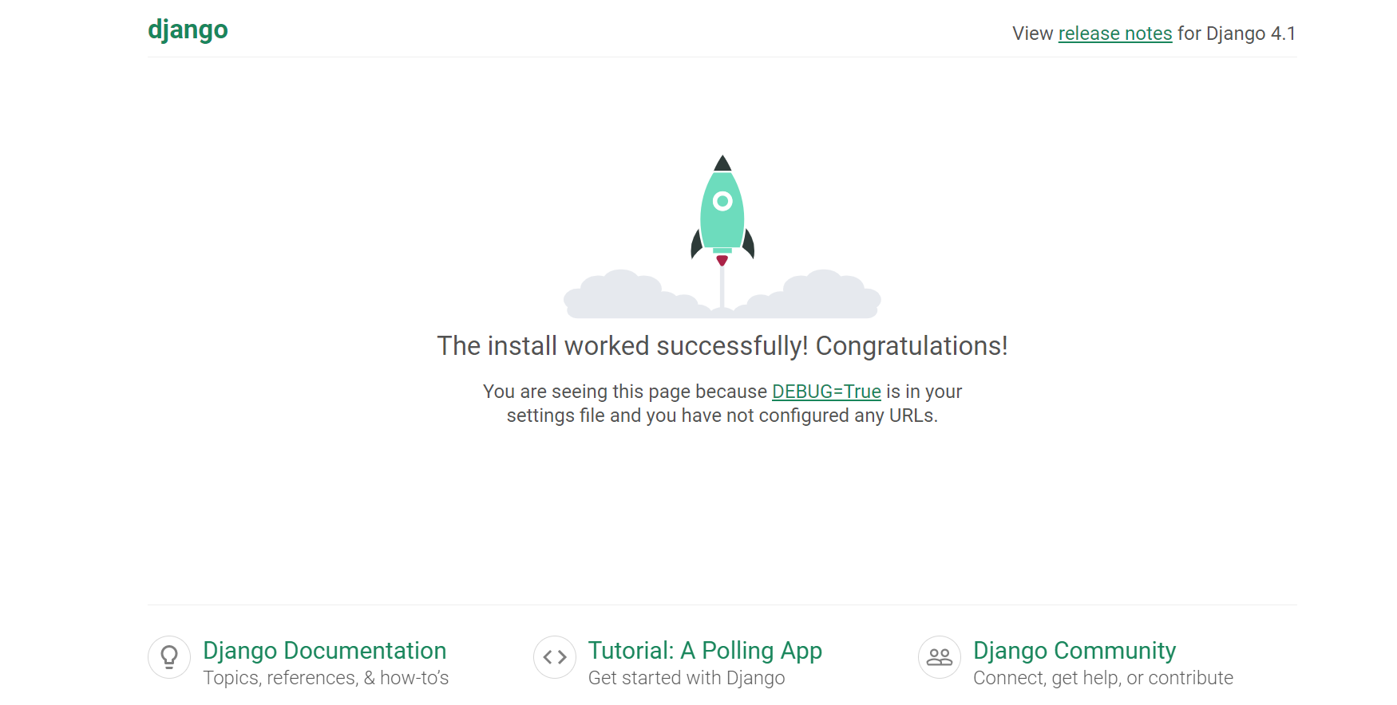

PS C:\Users\suba0816\PycharmProjects\pythonProject\djangotest\djangotest_project> pipenv --venv

C:\Users\suba0816\.virtualenvs\djangotest_project-tvDb8bOf